Remote Desktop URL:

<https://client.wvd.microsoft.com/arm/webclient/index.html>

# External Users – connecting from an untrusted device (Internet)

### For External users (i.e., users not on ZNA network or ZNA VPN)

#### Access Citrix website by using below link:

<https://zurich.okta-emea.com>

#### Please enter your credentials and click “Sign In”:

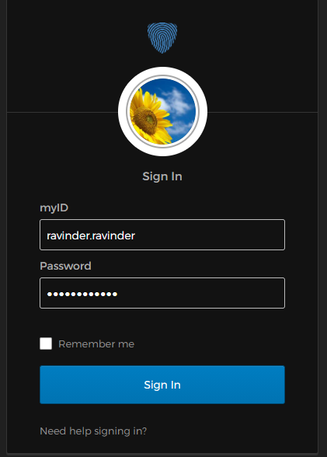

#### Click on “**Citrix ZNA – Zurich.com**” option from the list:

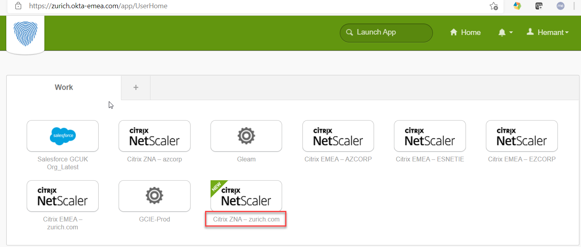

#### OKTA Authenticate - with Call, SMS, or Push (as per your configuration)

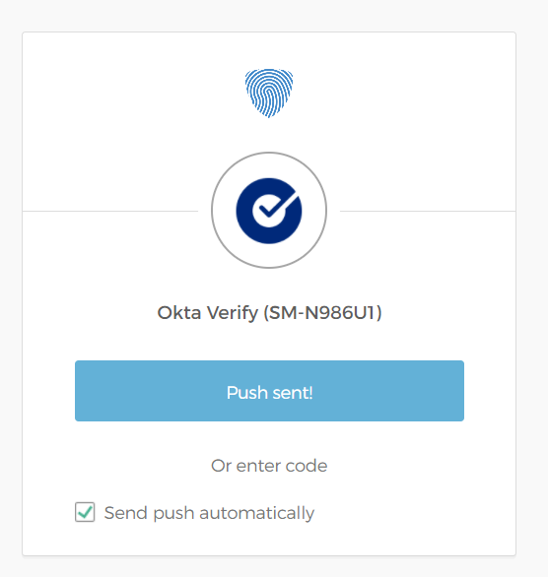

1. From the Apps Landing page select “Edge” and click “open”.

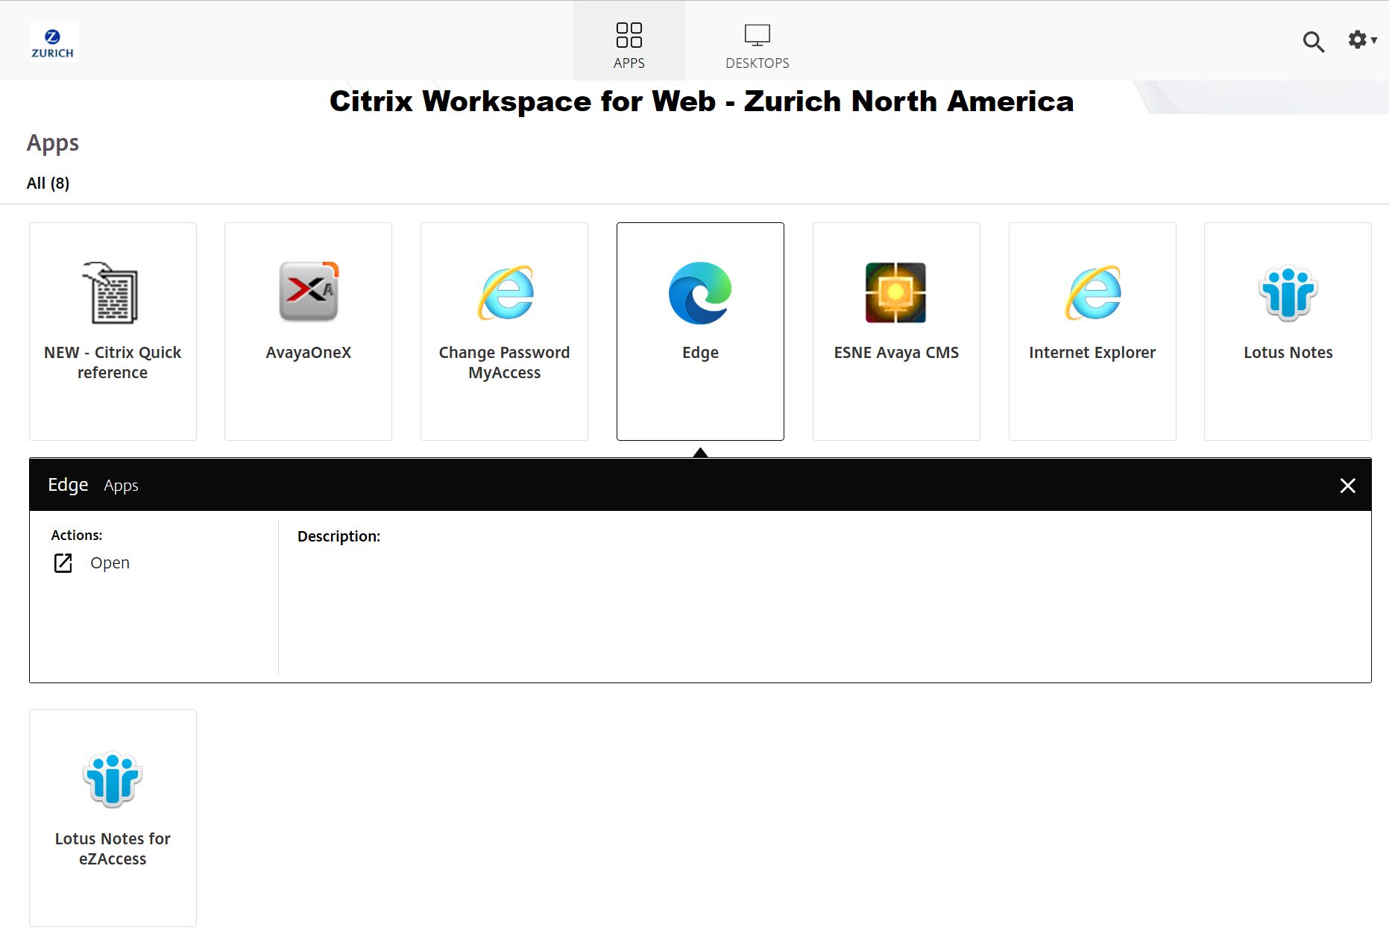

1. Once the browser opens navigate to the below link and follow the Internal Users section.

# Internal Users (VPN or LAN attached)

1. Use this link: <https://client.wvd.microsoft.com/arm/webclient/index.html>
2. Once the service automatically logs you in you will see your VM(s). Double click on the VM.

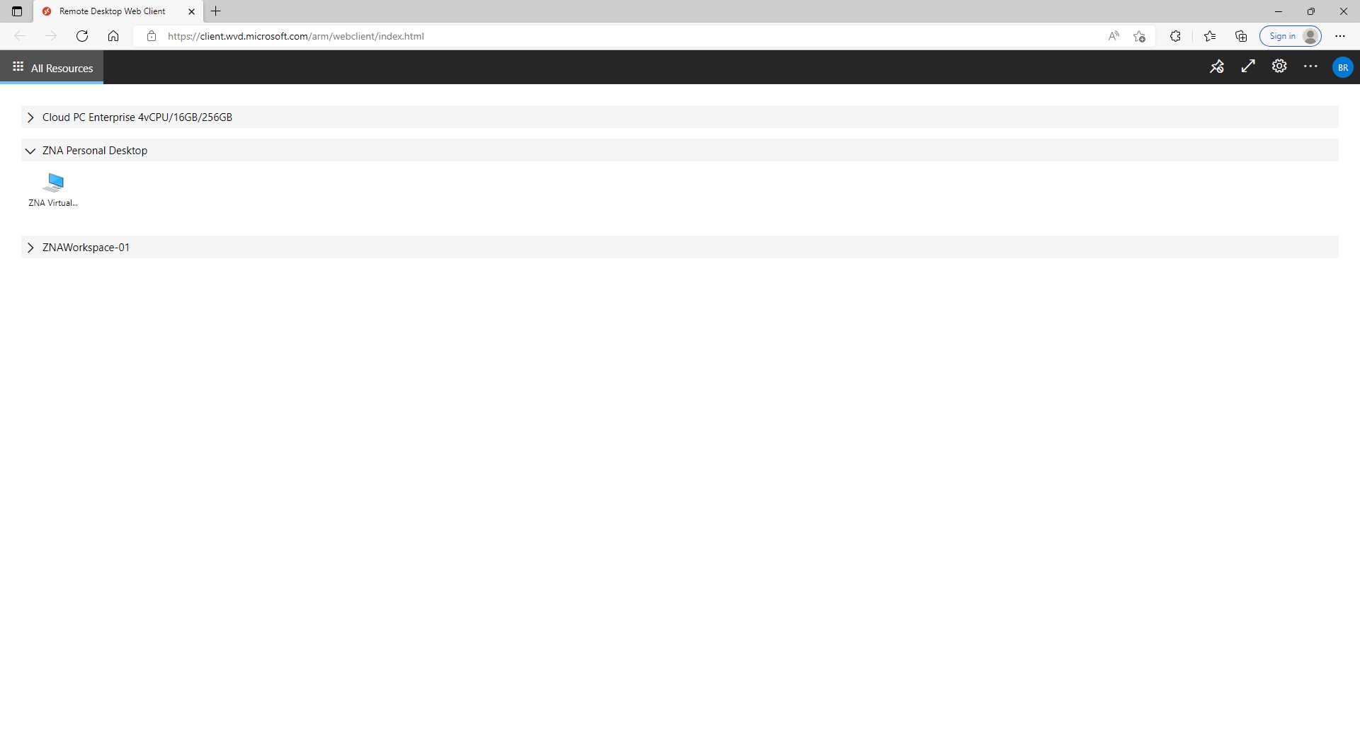

1. Click the Allow button to continue.

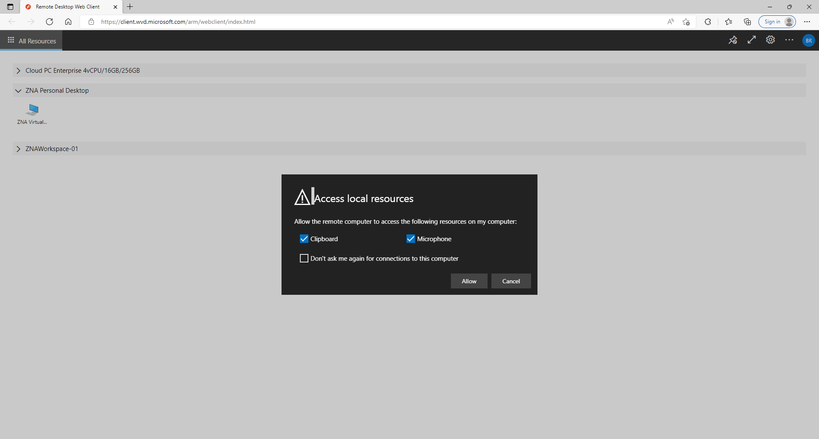

1. In the **Username** field type in *GITDIR\ + <Your MyID> (EX. GITDIR\Joesph.Smith)*
2. In the **Password** field type in your MyID password.

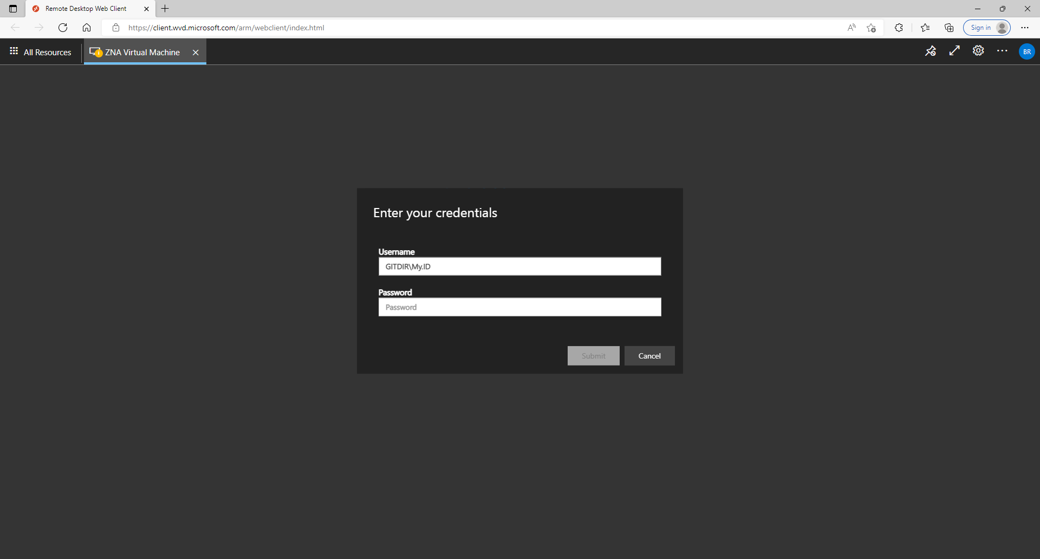

1. You may see the Setting up your device for work screen before you see the Desktop. Please wait a few minutes if this screen does show up.

